**Semester: V Name of Student:**

**Academic Year: 2022-23 Student ID:**

**Class / Branch: TE IT**

**Subject: Advanced Devops Lab (ADL)**

**Name of Instructor: Prof. Manjusha K.**

**EXPERIMENT NO. 09**

**Aim: To Understand Continuous monitoring and Installation and configuration of Nagios Core, Nagios Plugins and NRPE (Nagios Remote Plugin Executor) on Linux Machine.**

**Theory:**

**1 - Pre-requisite**

First requirement is to install Apache and PHP first. Use the following commands to complete it. And use commands to install required packages for Nagios.

manjusha@apsit:~$ sudo apt-get update

manjusha@apsit:~$ sudo apt-get install wget build-essential unzip openssl libssl-dev

manjusha@apsit:~$ sudo apt-get install apache2 php libapache2-mod-php php-gd libgd-dev

## 2 – Create Nagios User

Create a new user account for Nagios in your system and assign a password.

manjusha@apsit:~$ sudo adduser nagios

Now create a group for Nagios setup “nagcmd” and add nagios user to this group. Also, add nagios user in the Apache group.

manjusha@apsit:~$sudo groupadd nagcmd

manjusha@apsit:~$sudo usermod -a -G nagcmd nagios

manjusha@apsit:~$sudo usermod -a -G nagcmd www-data

## Step 3 – Install Nagios Core Service

After installing required dependencies and adding user accounts and Nagios core installation. Download latest Nagios core service from the official site.

manjusha@apsit:~$cd /opt/

manjusha@apsit:~$sudo wget https://assets.nagios.com/downloads/nagioscore/releases/nagios-4.4.3.tar.gz

manjusha@apsit:~$sudo tar xzf nagios-4.4.3.tar.gz

After extracting naviate to nagios source directory and install using make command.

manjusha@apsit:~$cd nagios-4.4.3

manjusha@apsit:~$sudo ./configure --with-command-group=nagcmd

manjusha@apsit:~$sudo make all

manjusha@apsit:~$sudo make install

manjusha@apsit:~$sudo make install-init

manjusha@apsit:~$sudo make install-daemoninit

manjusha@apsit:~$sudo make install-config

manjusha@apsit:~$sudo make install-commandmode

manjusha@apsit:~$sudo make install-exfoliation

Now copy event handlers scripts under libexec directory. These binaries provides multiple events triggers for your Nagios web interface.

manjusha@apsit:~$sudo cp -R contrib/eventhandlers/ /usr/local/nagios/libexec/

manjusha@apsit:~$sudo chown -R nagios:nagios /usr/local/nagios/libexec/eventhandlers

## Step 4 – Setup Apache with Authentication

Now create an Apache configuration file for your Nagios server as below:

manjusha@apsit:~$sudo nano /etc/apache2/conf-available/nagios.conf

Add below lines to nagios.conf file.

ScriptAlias /nagios/cgi-bin "/usr/local/nagios/sbin"

<Directory "/usr/local/nagios/sbin">

Options ExecCGI

AllowOverride None

Order allow,deny

Allow from all

AuthName "Restricted Area"

AuthType Basic

AuthUserFile /usr/local/nagios/etc/htpasswd.users

Require valid-user

</Directory>

Alias /nagios "/usr/local/nagios/share"

<Directory "/usr/local/nagios/share">

Options None

AllowOverride None

Order allow,deny

Allow from all

AuthName "Restricted Area"

AuthType Basic

AuthUserFile /usr/local/nagios/etc/htpasswd.users

Require valid-user

</Directory>

To setup apache authentication for user **nagiosadmin**

manjusha@apsit:~$sudo htpasswd -c /usr/local/nagios/etc/htpasswd.users nagiosadmin

Enable Apache configuration and restart Apache service to make the new settings take effect.cd

manjusha@apsit:~$sudo a2enconf nagios

manjusha@apsit:~$sudo a2enmod cgi rewrite

manjusha@apsit:~$sudo service apache2 restart

## Step 5 – Installing Nagios Plugins

After installing and configuring Nagios core service, Download latest nagios-plugins source and install using follocdwing commands.

manjusha@apsit:~$cd /opt

manjusha@apsit:~$sudo wget http://www.nagios-plugins.org/download/nagios-plugins-2.2.1.tar.gz

manjusha@apsit:~$sudo tar xzf nagios-plugins-2.2.1.tar.gznagios

manjusha@apsit:~$cd nagios-plugins-2.2.1

Now compile and install Nagios plugins

manjusha@apsit:~$sudo ./configure --with-nagios-user=nagios --with-nagios-group=nagios --with-openssl

manjusha@apsit:~$sudo make

manjusha@apsit:~$sudo make install

## Step 6 – Verify Settings

Use the Nagios commands to verify the Nagios installation and configuration file. After successfully verify start the Nagios core service.

manjusha@apsit:~$/usr/local/nagios/bin/nagios -v /usr/local/nagios/etc/nagios.cfg

manjusha@apsit:~$ sudo service nagios start

Also configure Nagios to auto start on system boot.

## Step 7 – Access Nagios Web Interface

Access your nagios setup by access nagios server using hostname or ip address followed by /nagios.

[**http://127.0.0.1/nagios/**](http://127.0.0.1/nagios/)

Prompting for Apache Authentication Password –

**username: nagiosadmin**

**Password : 123456 (which you enter while configuration)**

**Nagios After login screen –**

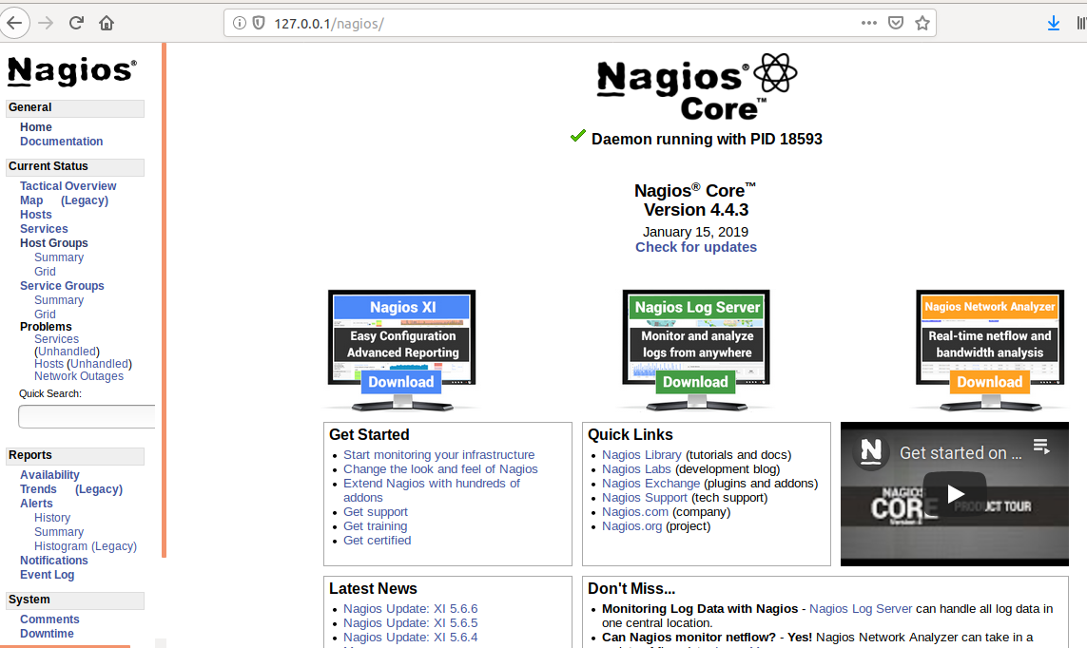

We have successfully installed and configured Nagios Monitoring Server core service in our system now we need to install NRPE on all remote Linux systems to monitor with Nagios.

**Conclusion: Write your own findings.**